Painting outdoors, or as the French say, 'en plein air'.
Almost every art tutorial book you read on painting landscapes recommends that one paints outdoors, direct from nature. While it requires much more planning than painting from photos, it gives rewards directly proportional to the effort expended. The most important element in any painting is composition, and painting 'live' affords the individual the option to include his perception of the important features and atmosphere of what he views. Invariably the completed composition is quite different to a photograph of the same subject. It's not easy, one has to be prepared for wind, bright sun and sunburn, cold, heat, tourists (there's always someone who wants to chat) and of course, getting all your gear to a site that, 'floats your boat'.
Autumn is the best time of year, particularly for painting outdoors, direct from nature. Members of the Society of Artists Newcastle recently spent five days painting at the annual 'Mudgee Paintout' with about thirty artists from all over the country. Access was organised to Beaudesert, an historic farming property, to Martin's Hill vineyard, to the local Mudgee 'wetlands', and Hill End, in beautiful Autumn weather. This was followed by a four day painting excursion by a small group to Seal Rocks. These trips always produce art work, sketches and ideas, as everyone involved is there to paint. They also offer feedback and productive critiques from experienced painters and of course, cross pollination of ideas and techniques.
While these types of group outing are ideal, you don't have to travel to paint plein air. There's plenty of subjects in our own back yard begging to be painted. Newcastle, Lake Macquarie, the harbour, Port Stephens and the Hunter Valley are the envy of most people around Australia. The more you paint outdoors, the more practice and experience you gain to manage and master the perceived obstacles. Most importantly, your work will improve. So get to it, make it happen. Paint on your own, or with friends. Much more fun and supportive with a group, and a lot to discuss over a cup of coffee.

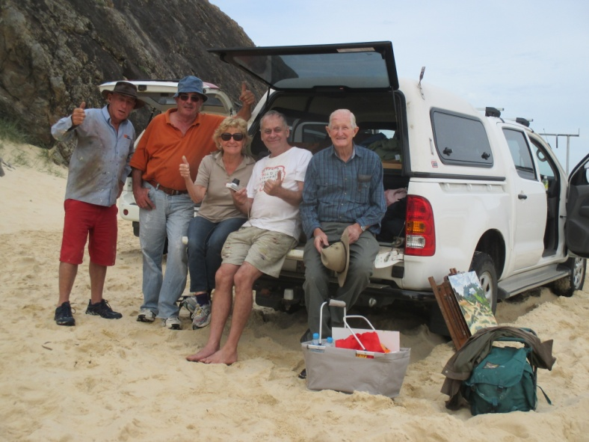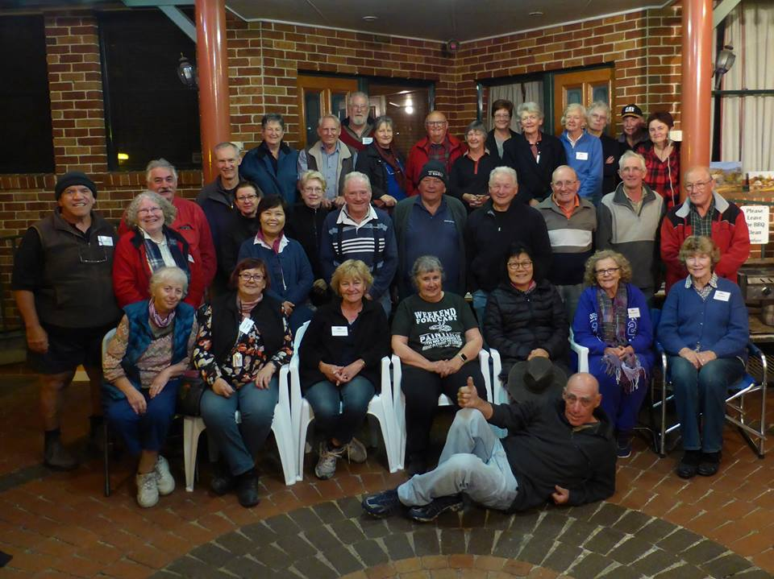
On the beach at Seal Rocks Smiling faces at Mudgee 2016

