2016
Annual Report

Report for the Year 2016 for presentation to the
Annual General Meeting at 7.30pm Monday 27 March 2017

Agenda

- Meeting Open
- Apologies
- Confirmation of Minutes of last Annual Meeting
- President’s Report
- Treasurer’s Report and Financial Statements
- Other Reports
- Election of Office Bearers
- Special resolution –
  - That a special once-off levy of $50 be payable by all new and renewing members, together with the normal membership fees due on 1 July 2017, to be used to assist fund the approved building extensions.
- General Business -
- Items for referral to the incoming Executive Committee
- Meeting Closed

MINUTES OF THE ANNUAL GENERAL MEETING 28 MARCH 2016

(An Annual General Meeting was conducted from 7.00pm on Monday
28 March 2016 The meeting followed an ordinary meeting of the Executive Council and was attended by over 30 members, as recorded in the Attendance Book. A record of the minutes was not taken.

As nominations received by the prescribed closing time did not exceed the number and/or designations of the vacant positions on the Council, an election was not necessary and the following people were appointed to the vacancies for the ensuing year 2014:-

PRESIDENT Hugh Cross
VICE PRESIDENT Gwendolin Lewis
SECRETARY Chris Finch
TREASURER Jenni Gander
ART DIRECTOR Lee-Anne Corrigan
PUBLICITY OFFICER Bob Saxon
LIBRARIAN Margaret Schroder
MEMBERSHIP SECRETARY Elaine Collin
NEWSLETTER EDITOR Ron Deas

COMMITTEE Jill Campbell (& Webmaster)
Judy Hill
Ron (Joe) Donkin
Phil Bamford

Non-Members of the Executive Council

SOCIAL SECRETARY Elaine Collin
PUBLIC OFFICER Cliff Hosking

Written Reports from the outgoing Executive Council for 2015 including that of the President, the Librarian, the Membership Secretary and the Treasurer’s Financial Reports had been circulated prior to the meeting and were tabled.
The Social Secretary and Art Director presented verbal reports to the meeting.

The incoming president, Hugh Cross thanked the outgoing Executive Council and congratulated the incoming Council on their appointment, and declared the Annual Meeting closed.

Presidents Report

2016 proved to be yet another successful year for our beloved society, with sustained membership, a very active membership and a sound financial position. Moreover, our members had fun making, displaying and selling their art, or just improving their skills and enjoying ‘the moment’ when painting.

The Society’s three major annual exhibitions, the Newcastle Art Prize, the Raymond Terrace Market Place Shopping Centre Exhibition, and the Portrait Painters Hunter’s ‘Let’s Face It!’ exhibition, all went very well. Sales were down somewhat however, particularly for the Raymond Terrace Exhibition, for reasons that remain unclear. On most occasions, we manage sales in the 20 to 25% range, but this year was half that. The NAP again achieved about 10% in sales. Thank you to everyone who helped plan and resource our various exhibitions.

Of course sales are only part of the story, attendance at each of the exhibitions was pleasing, and for the NAP, the main and section prizes backed by our wonderful sponsors saw some $6,900 distributed in prizes to winning artists (both members and non-members).

Through Ron Deas, the Society also held a half day exhibition at the Valentine Public School’s “Market Day” on Saturday 5 November. Although sales weren’t forthcoming, it was an opportunity to showcase the Society and quite a few attendees were interested in becoming members. Members were also able to exhibit their works at three of the Hunter Arts Network’s (HAN) Art Bazaars, that were held in autumn, winter and spring. Quite a few paintings were sold on each occasion, and Stephen Cassettari was a constant draw-card for his hand painted Chinese style cards. And finally, there was our inaugural ‘Selfies’ Exhibition of self-portraits by members of the Portrait Painters Hunter (Monday morning) group, as well as a series of exhibitions by our members at the Waratah Campus of the John Hunter Hospital.

Sadly, 2016 saw a number of Society stalwarts pass on, including Dudley Lewis, a long-term member of the society, and a regular participant in the portrait group in recent years, as well as John Hipwell at age 93.

It being many years since name badges were last ordered, a new design was developed for members to purchase at $13 each. They are held in place with a magnetic matching piece so that you can easily move it from one item of clothing to another. These proved popular and are ever so handy for jogging your memory as to who’s who!

Throughout the year, Bob Saxon put a great deal of effort into progressing the extensions to the rooms, culminating in the approvals from the Department of Lands and Newcastle City Council. When reviewing the various quotes it was realized that modifications were needed to both reduce the costs to an affordable amount and to improve the capacity of the extensions to be used for multiple uses. Right now we are seeking approval for those modifications and have resolved that we can afford to proceed if we augment our Society’s funds by a special once-off levy of $50 per member to raise about $15,000. This special levy needs to be ratified by a special resolution at this Annual General Meeting. I commend it to you, as the extensions will alleviate the problems with our failing shipping container whilst also giving us a much enhanced capacity to hold larger events and also run multiple activities concurrently.

To keep the builders’ quotes in the affordable range we will still need to do some handiwork ourselves. Bob has kindly offered to lead some teams to fit out the interior of the new extension and to demolish the internal rooms at the far end of the main room prior to the building work starting. So, keep an eye out in the newsletter for your opportunity to put your hand up with the time comes!

Lee-Anne Corrigan has done a fabulous job in her first year as Art Director arranging a fabulous array of workshops. Behind the scenes, Pam Carrol has been quietly and efficiently performing wonders as Purchasing Officer. Ron Deas has also been a bastion of quiet efficiency as he has produced the monthly newsletter to keep us all informed, assisted by Bob Saxon who folds and mails out the hard copies. Please if you can – put yourself down to receive the email copy only, and/or please put your hand up to help with the monthly mailing process! And of course, Jill Campbell has been keeping the Society’s website (www.societyofartistsnewscastle.com) up to date with all manner of news and events – thank you! And a big thank you to Jenni Gander for tirelessly (well, perhaps a little tired!) doing all the banking, accounts and special arrangements for exhibitions and so on. On behalf of my self and all of you, I am most grateful for the hard work of all the other committee members, without whom we wouldn’t be able to enjoy the rooms or the events that they make possible.

Hugh Cross

Treasurer’s Report
The Society made a trading surplus of $5,635 and an annual net loss of some $40 after rent, rates and taxes. We ended the year with accumulated funds of $58,446 as at 31st December 2016. The audit statement and Financial Report by the Society’s auditor are provided below.

Jenni Gander

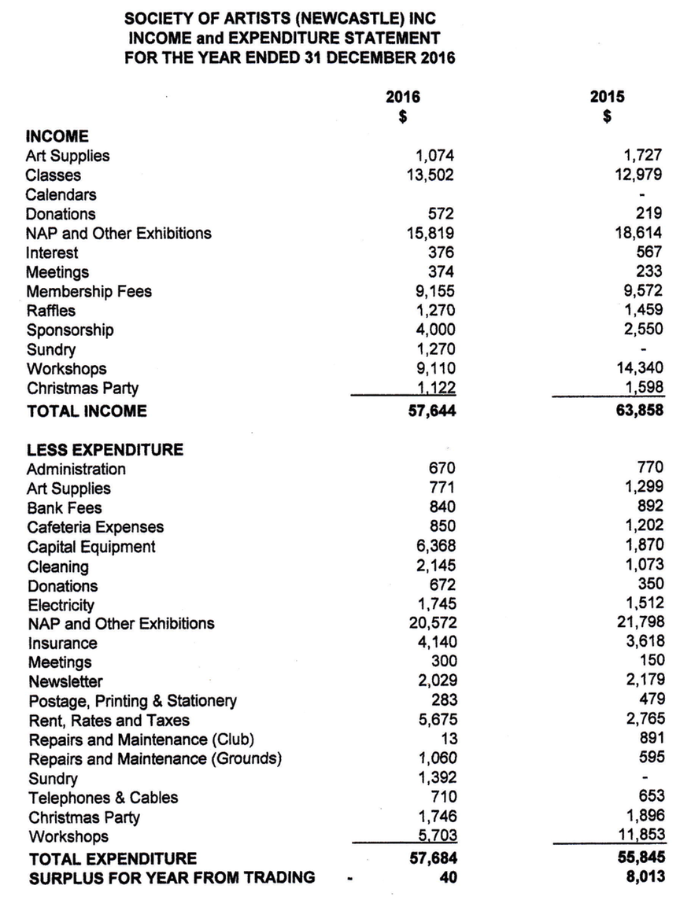

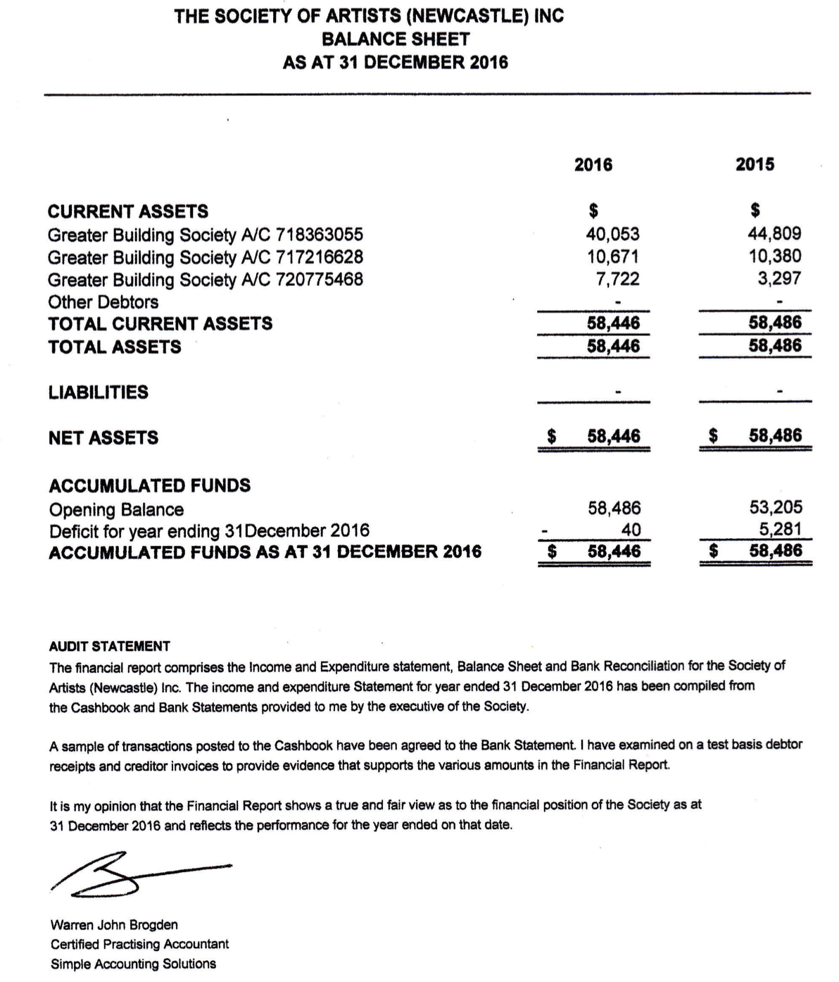

Other Reports

Secretary’s Report
Minutes for all Committee meetings were recorded. Letters of thanks to sponsors, past clients who purchased art works, and special members of the community were posted including invites to the opening night.
This year for the first time email invitations were also sent out with a good response.
Thank you
Christine Finch

Membership Secretary

The Society of Artists have 352 members listed on our membership, of which 47 were new members from March 2016, whilst 14 are various organisations, principally our sister art societies.

Kathy Loudon

Art Director

I took over the role of Art Director from Jenni Gander twelve months ago. I was excited to plan and organise the workshops for our society members and their friends. I found all of our tutors to be excellent teachers as well as very charming people. I had so many comments from patrons about their favourable experiences at a workshop. They would say their excitement was stirred for their own artwork by the new lessons learned, or they made notes about interesting tips they gleaned from professional artists who shared from their wealth of knowledge. Often the tutors are very prepared to instruct with their own photos as well as written notes that are essential to our open minds for developing our art journey.

We do try to cater for different levels of artistic experience, so people need not feel daunted about their ability in a class. Tutors are very helpful with all individual needs. Recently we held a Beginners Watercolour class with Lauren Sahu- Khan who is a new tutor to watch for, also Tony White is a very generous watercolour tutor we will have again in 2017. The workshops are very reasonably priced, between $50 - $70. Our weekend workshops are specially priced to cater for more substantial learning and in 2016 we had Jacky Pearson (watercolour) , John Rice (oils) and Judith White (mixed media) .

All up in 2016 we had 16 workshops, with watercolour being particularly popular with our members. Local artists, Annie Palmer and Rhonda Parcel teach mixed media and Noeline Miller is a popular Acrylic artist that we have returning in 2017.

I advise people to first ring me to make their booking and follow that with their direct debit payment a couple of weeks prior to their workshop. Sometimes it is necessary to have a waiting list for tutors.

Looking forward to 2017!

Lee-Anne Corrigan
Art Director

Publicity Officer

Many thanks to our regular sponsors for their continued support in 2016. Aaron Framed It, Adamstown Newsagency, Elders Real Estate, Newcastle Herald, Port Waratah Coal Services, and Simpson Shoes once again pitched in to support our 2016 Newcastle Art Prize art exhibition (NAP).

We welcomed Escape Travel, Daniels Recruitment and Awesome Newcastle as inaugural sponsors and while Awesome was by definition a 'once off' event, hopefully Escape Travel and Daniels Recruitment will continue with us in 2017 in supporting the visual arts in Newcastle. NAP advertising was widespread with newspaper ads and via radio exposure in the Newcastle area. Our exhibition was also advertised in Australian Artist.

For the 2017 Newcastle Art Prize, we have our regulars helping out once again and we are actively engaged in following up new supporters. Looking forward to our major event of the year, which I'm sure will be another successful event, both financially and artistically.

Bob Saxon

Librarian

Our library has been doing well in the last twelve months. I have added 36 new books this past year – with a wide range of interest that would suit everyone. Only four new DVD's were added, however I will hopefully purchase a few more in the next couple of months.

Always check where I display the new books and DVD's so you will know what has come into the library. We have a wonderful library so why not make the best of it? If I can assist you please do not hesitate to ring me at the office or at my home. If you are looking for a specific book please let me know, and don’t forget to use the library directory which is there for everyone. We are very lucky to have a great library in our fine rooms.

Margaret Schroder

Webmaster for the Society’s Website (www.societyofartistsnewcastle.com)

Having taken over the Webmaster position from Hugh in 2016, it has been a steep learning curve for me – and I am still learning. I do thank Hugh for all the help and support he has provided from time to time during the year.

In most areas I have tried to continue the pattern Hugh has developed for the Website when he first set it up. V isual changes have been adding more of our members art work to the “headers” at the top of each of the pages.

The concept for the Website is that it will inform the general public about the activities, such as workshops, groups and exhibitions available. It is not intended to give specific information for members of the Society that is available in the Newsletter.

In an average month the website receives over 600 views, whilst over 200 people actually visit the website.
The most frequently checked pages are Contact Details for the Society, Workshop Information and Urban Sketching Information.

Linked to the Website is the Society email which receives about 20 emails per month – about half of these are “bulletin” type mail from art related sites and other mail, usually enquiries, is usually forwarded to relevant members.

Jill Campbell

Record of Attendance at Executive Council Meetings

(Provided in accordance with the requirements of
Clause (11) 2 e (ii) of the Constitution)

Council Member Possible Meetings* Actual Attendance

Hugh Cross: 13 13
Gwendolin Lewis : 12 9 (resigned 30 January 2017)
Christine Finch: 13 12
Jenni Gander: 13 13
Lee- Ann Corrigan: 13 9
Kathy Loudon: 13 8
Ron Deas : 13 9
Margaret Schroder: 13 7
Jill Campbell: 13 10
Bob Saxon: 13 13
Phil Bamford: 13 4
Joe Donkin: 13 9
Judy Hill: 12 9 (resigned 06 February 2017)
* 11 monthly meetings, plus 2 special planning meetings.

Office Bearers for 2017

The following positions are to be filled:-

Members of the Executive Council

President ……………………………………………..

Vice President ……………………………………………..

Secretary ……………………………………………..

Treasurer ……………………………………………..

Art Director ……………………………………………..

Publicity Officer ……………………………………………..

Membership Secretary ……………………………………………..

Newsletter Editor ……………………………………………..

Librarian ……………………………………………..

Committee (4) ……………………………………………..

……………………………………………..

……………………………………………..

……………………………………………..

Not Members of the Executive Council

Social Secretary ……………………………………………..

Public Officer ……………………………………………..

Webmaster ……………………………………………..

Newsletter Assistant Editor ……………………………………………

Purchasing Officer ……………………………………………...

Notes

