2017 Annual Report

Report for the Year 2017 for presentation to the
Annual General Meeting at 7.30pm Monday 26 March 2018

Agenda

- Meeting Open
- Apologies
- Confirmation of Minutes of last Annual Meeting
- President’s Report
- Treasurer’s Report and Financial Statements
- Other Reports
- Election of Office Bearers
- General Business -
- Items for referral to the incoming Executive Committee
- Meeting Closed

MINUTES OF THE ANNUAL GENERAL MEETING 27 MARCH 2017

26 Members present as per the attendance book kept in the society rooms.
Apologies: Gwendolin Lewis, Judith Hill.
Meeting opened by Hugh Cross at 7.10pm.
2016 compiled written Annual Report was handed out to all members present for the meeting.
Hugh welcomed all members and thanked them for attending.
Minutes of the 2016 AGM were read and accepted by all members present.
Prop Paul Durrell / Sec Cliff Hosking

Committee Reports:
Hugh informed the members that we now have 352 members in the society at present and the society has performed very well in the 2016 year to date.
Hugh explained the Presidents and Treasurers report with reference to the 2016 balance sheet with the auditor’s statement. General discussion followed with a general overview of committee member’s contributions for the 2016 year.
Hugh thanked the three retiring members of the Executive, Gwendolin Lewis, Judy Hill and Lee-Anne Corrigan, for their significant contributions to the Society.

Election of the Executive Council and Non-Executive Positions:
Returning Officer Ron Deas conducted the election of officers as following:
Position | Name | Proposed | Seconded
President | Hugh Cross | Bob Saxon | MDRee
Vice President | Bob Saxon | Hugh cross | MDRee
Secretary | Clare Felton | Christine Finch | Hugh cross
Treasurer | Jenni Gander | Hugh Cross | Christine Finch
Art Director | Vacant
Membership Secretary | Kathy Loudon | Judy O’Neill | Wendy Fengler
Newsletter Editor | Peter Anson | Eleanor Anson | Hugh Cross
Librarian | Margaret Schroder | Kathy Loudon | Judy O’Neill
Publicity Officer | Reg Baty | Hugh Cross | Ron Donkin
Webmaster/Committee  Member | Jill Campbell | Bev Leggett Simmons | J Maundrell Hall
Committee Member | Ron Donkin (Joe) | Hugh Cross | Christine Finch
Committee Member | Julie Hvirf | Hugh Cross | Terry Holdom
Committee Member | Phil Bamford | Jenni Gander | Christine Finch
Public Officer | Cliff Hosking | Lynette Streete | Hugh Cross
Purchasing Officer | Pam Carroll | Hugh Cross | Sue Linton
Social Secretary | Elaine Collin

Due to personal commitments, Lee- Ann Corrigan is unable to continue on as Workshop Director so nominations were called form the floor. No members present were able to take on the role, so it will be left for the new committee to resolve.
The returning officer also mentioned that Ron (Joe) Donkin and Margaret Schroder had been on the committee in the same roles for longer than the constitutional 3 year period*. All members voted in favour for Margaret and Joe to continue on in their current positions.
(* Hugh Cross has also been in the role of President since 2014 and hence should also have been include in the resolution, but due to an error was not).

Special Resolution:
That a special once-off levy of $50 be payable by all new and renewing members, together with the normal membership fees due on 1 July 2017, be used to assist fund the approved building extensions.
Proposed by: Bob Saxon Seconded by: Cliff Hosking
All members present voted unanimously to accept the $50 once off levy.
Amendment 1 to Special Resolution:
That any existing member who chooses not to renew their membership in the 2017 will be required to pay an additional re-entry fee of $50 in the 2018 and 2019 financial year plus membership.
Proposed by Jenni Gander/ Seconded by Verona Lucas
Amendment 2 to Special Resolution
Where there are two members from the same family who are society members, that family will only have to pay a single once off $50 levy.
Proposed by Bob Saxon /Seconded by Ron Deas
There was unanimous acceptance by all present for the special resolution, and amendments 1 and 2.

Hugh informed all attending members that the adjusted plans have been accepted by the Lands Department. Adjusted plans have now been resubmitted to the Newcastle City Council.
New quotes will be needed when the plans are returned from the Newcastle City Council. Hugh explained that all 352 members owned the rooms and not many other societies have that luxury.
Bob explained to the members the basic design and floor plan of the new extensions and answered queries from the floor.
Bob suggested that the society have a few working-bee days to finish off the internal requirements needed to make the room functional.
Julie Hvirf informed the members that the Westpac bank are offering grants of $10,000 for small community based non for profit groups and it would be in the society’s interest to apply.
Hugh explained that the Society has also applied for grants from private companies and government groups.

General Business
Hugh advised that the rooms were burgled two weekends before the AGM, and that temporary remedial actions have been made to minimise the chance of further break-ins. The issue will be looked at by the incoming committee to identify all actions needed for the long-term security of the rooms.

Meeting closed 7.50pm

2018 Presidents Report

Twelve months ago at the AGM, the Society members took a momentous and courageous decision to proceed with the extensions of the rooms. It was not a decision made lightly as it would use all our financial reserves and required the passing of a special resolution to levy a once-off $50/member contribution to cover the short-fall. Well, less than 12 months on we completed the project, thanks to the willingness of all you members to help with that financial contribution, and thanks to the many volunteers who worked to line and fit-out the extensions to keep the cost affordable. Again, on behalf of the Society, I thank our Vice President, Bob Saxon, for his initiative and leadership to make this happen.

All this culminated in the recent inaugural exhibition by Joe Donkin’s Friday outdoor group members, a fitting tribute to Joe for all that he has done for the Society. As will be reported on in the next newsletter, that exhibition was a resounding success, proving the capacity of the extensions to easily display 40 paintings to advantage. With over 25% sold, it was also a financial success providing about $740 in commissions to help rebuild the Society’s funds. We were also recently successful in securing a $6,533 grant from the NSW Government’s Building Better Communities Program that will enable us to complete the fit out, including installation of an air-conditioner.

Conversely, sales at the Raymond Terrace Market Town Exhibition, already down to 10% in 2016, were lower again in 2017 at 4%. Consequently, the Committee decided that it would not be worth while running it again this year. Although one can never be sure, possible reasons include exhausting the market in that area, the tougher economic times, and the competition from other exhibitions.

However, sales at the Newcastle Art Prize were similar to previous years, and once again we are very thankful to the Adamstown Uniting Church for allowing us at minimal cost to use their hall for that exhibition, and for also the Portrait Painters ‘Hunter’s ‘Let’s Face It!’ exhibition. As ever, the 2017 Hunter ‘Let’s Face It! Exhibition attracted a large number of viewers on opening night and was well received. In 2018 it will be held on the weekend prior to the AGM so I can not report on it here. The Society also held sites at the three Art Bazaars run by Hunter Arts Network’s (HAN), with the one in Lambton Park also providing the opportunity to showcase our rooms, as well as sell works from there.

In the minutes of the last AGM you may have noted that the position of Art Director was vacant as Lee-Anne Corrigan was having to step down for other commitments. However, being such a stalwart, she again took on the role subsequently with others helping to host particular workshops to lessen the load. Ultimately, when she did stand down in late 2017, Jenni Gander took on the coordination of the remaining workshops for which we are most appreciative.

All the members of the committee (formally known as the Executive in the Constitution) have worked hard and helped make 2017 a success. Peter Anson rapidly built his skill in the publishing arena to produce the 11 monthly newsletters, showing great persistence and dogged determination to see the job through to everyone’s satisfaction each time – a big thank you to Peter! Whilst on the newsletter, I note that many societies charge a higher membership fee for hard copies to cover the costs, than they do email only members. The other reason is that some poor volunteer has to print, fold, stuff envelopes and post the hard copies, no small task when you’re talking over a 120 copies! So please, consider requesting the email version of the newsletter, and/or helping with the envelope process.

Finally, on behalf of the society and myself I’d like to thank everyone who has pitched in throughout the year to make all of our achievements possible. This coming year we will see just what a boon our new extensions are, providing easy access to our display boards and an adaptable new room for art workshops, exhibitions and other uses.

Hugh Cross

Treasurer’s Report
Well, 2017 certainly saw a change in the accounts for the Society; however, we gained a valuable exhibition and workshop space which will enable the society to grow even more as an excellent community venture in the local art world. A big thank you should be offered to everyone who helped bring the extension to fruition, lots of hard work for nothing more in payment than the love of it all.

Overall, at the time of writing, we finished the year with a small trading loss considering the turnover in the accounts and we will slowly bring the accounts back to an even keel in the next year or so. In fact with the receipt of the Building Stronger Communities grant after the auditor’s work, we are in the black well and truly.

The Financial Reports by the Society’s auditor are provided below.

Jenni Gander

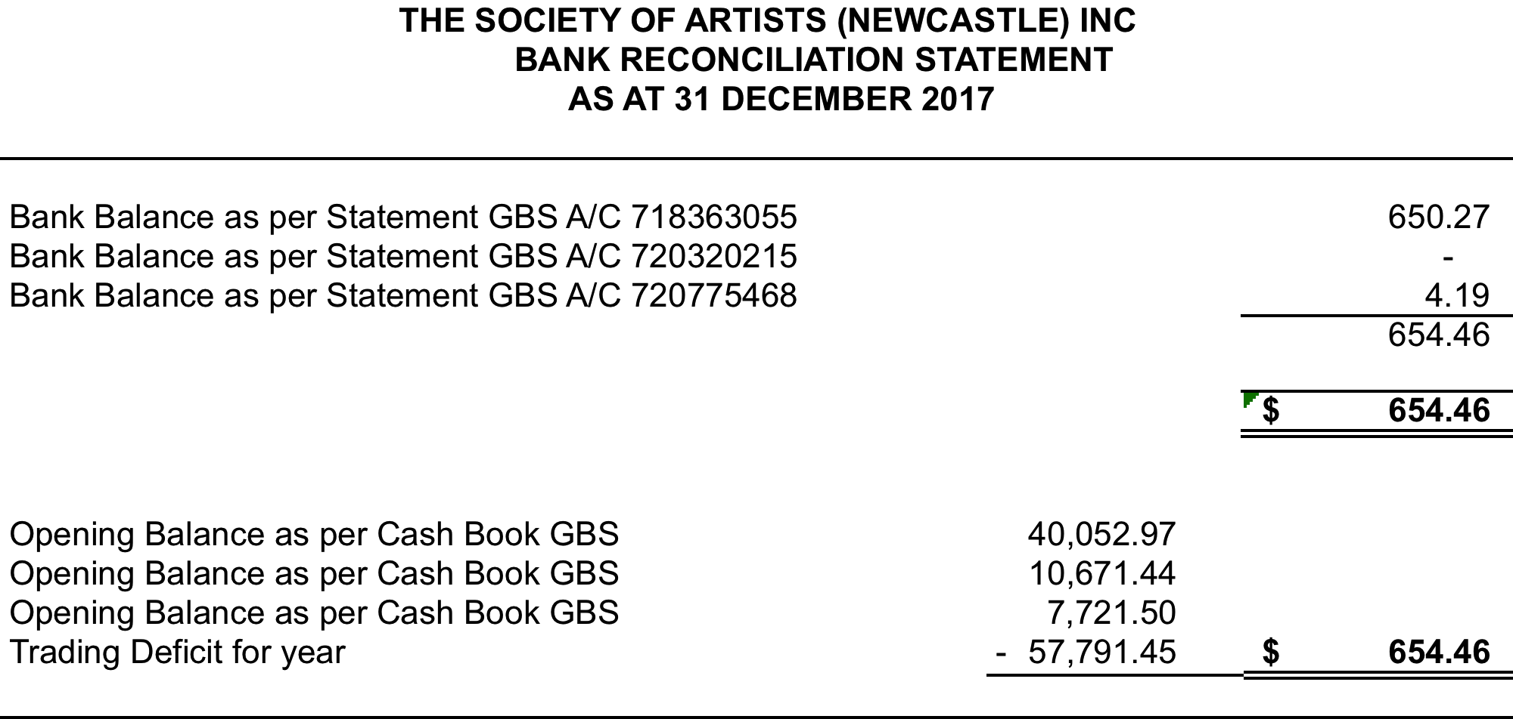

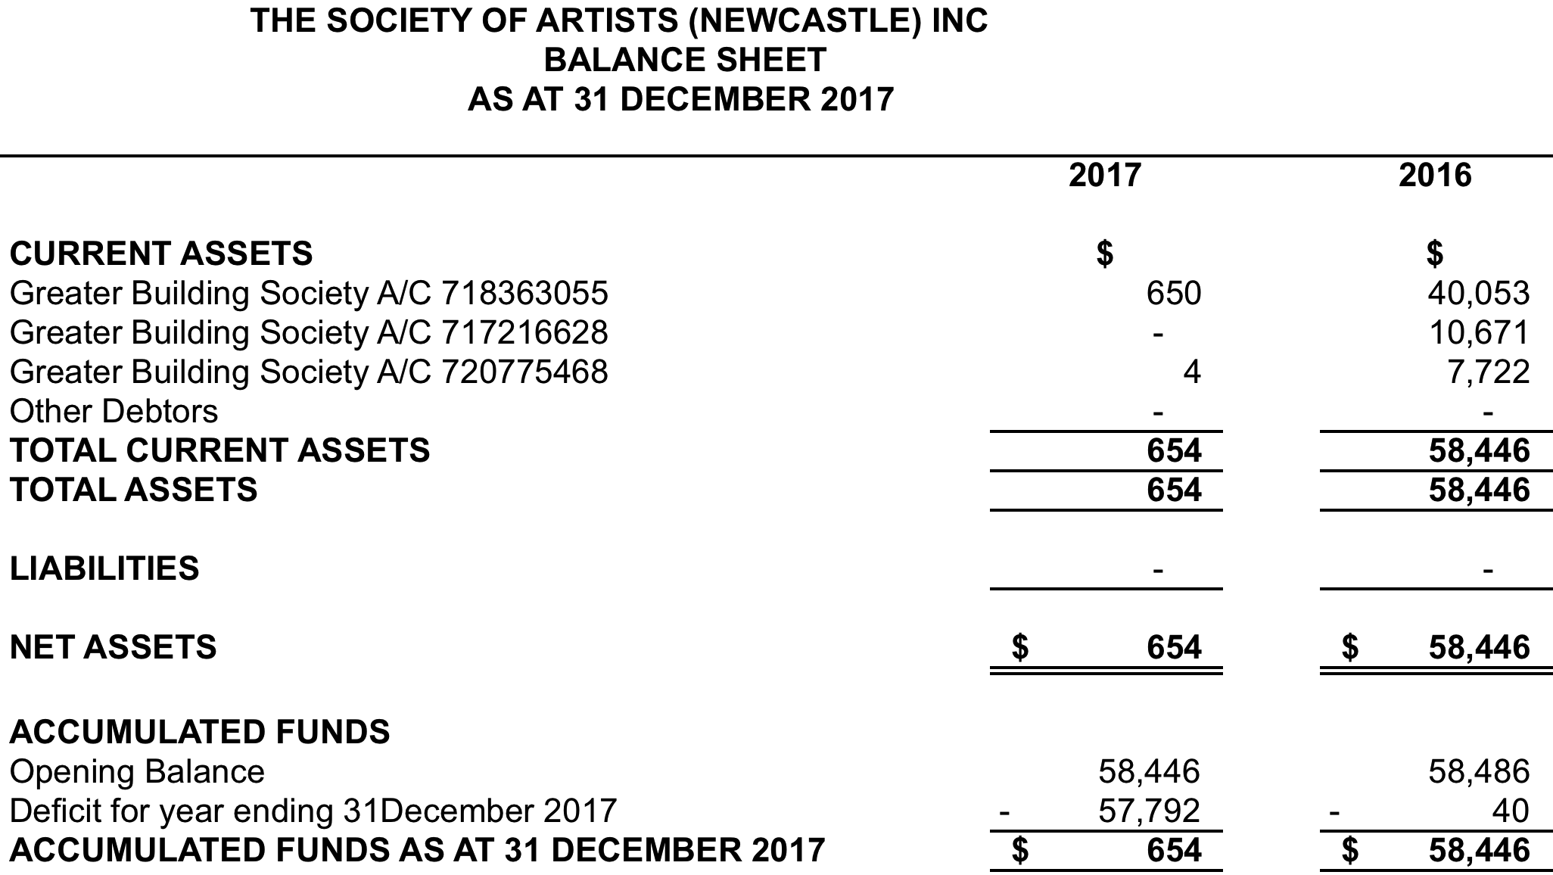

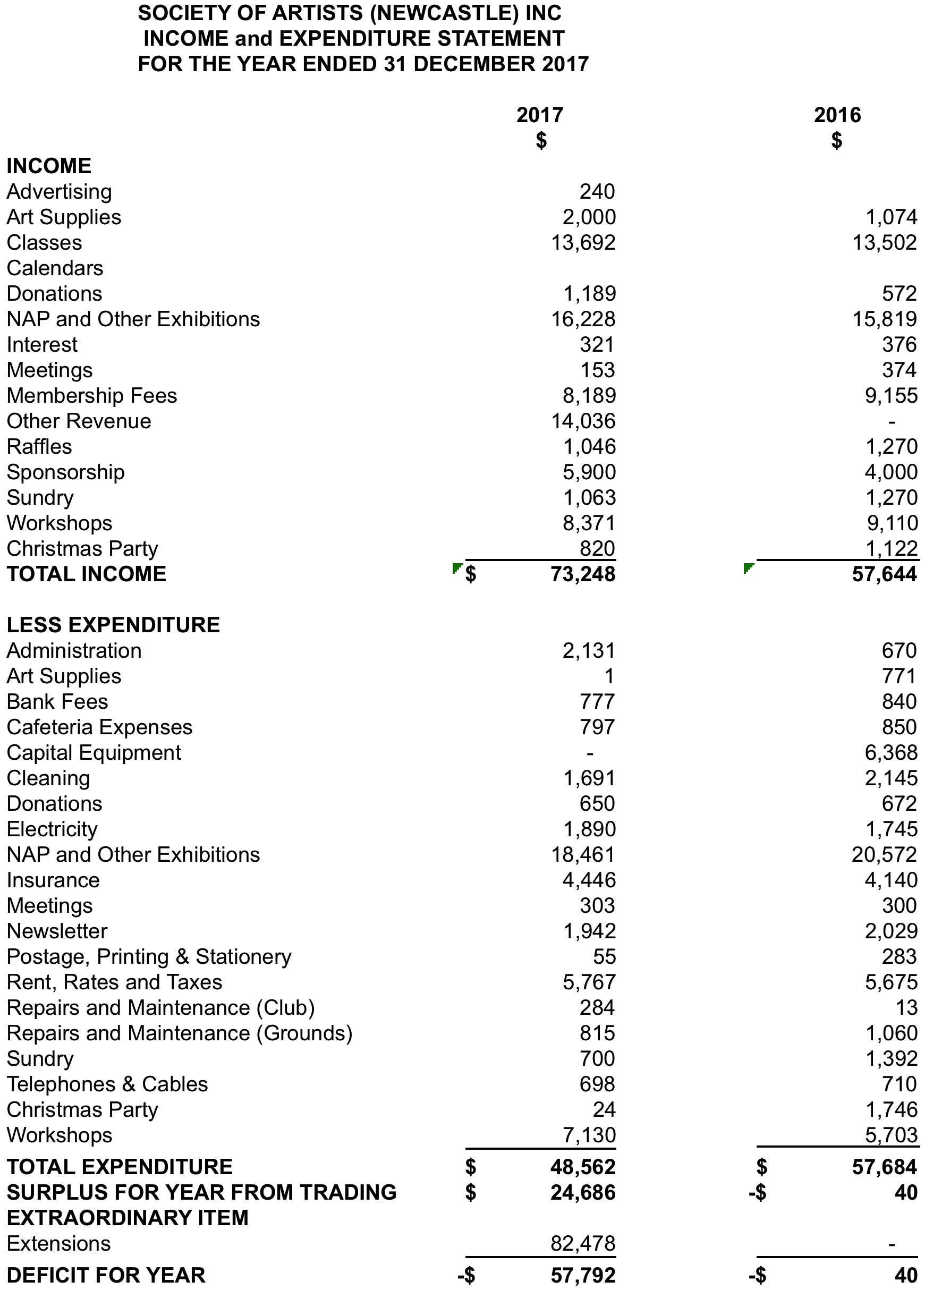
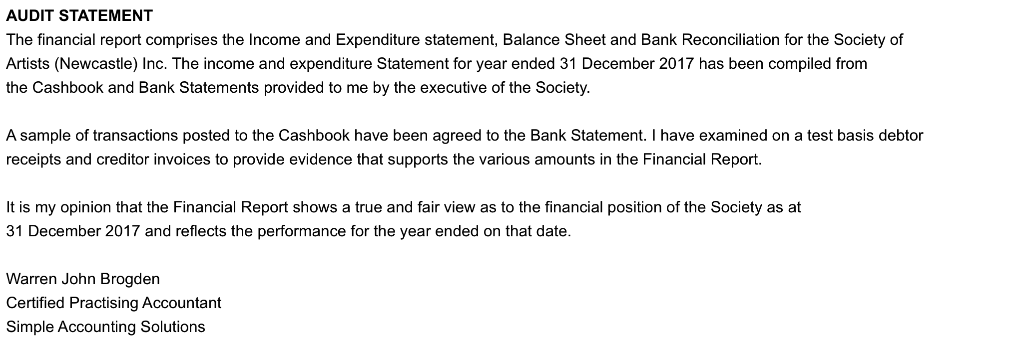
Other Reports

Secretary’s Report
Minutes for all Committee meetings were recorded. Letters of thanks to sponsors, past clients who purchased art works, and special members of the community were posted including invites to the opening night. Again this year email invitations were also sent out with a good response.

Clare Felton

Membership Secretary

As of March 2018, the Society of Artists has about 320 members, which is slightly down from February 2017 when there were about 350. This may in part due to the special once-off levy of $50/member to fund the extensions.

Kathy Loudon

Art Director

Lee-Anne Corrigan continued as Art Director in 2017 despite working full time and studying. However, late in the year Lee-Anne advised she needed to concentrate more on study and resigned as Art Director. The committee wishes to sincerely thank Lee-Anne for an excellent job of arranging different tutors and attendees for the classes and for providing many home cooked slices and cake for everyone.

Lee-Anne arranged 20 tutorials for 2017, but sadly 7 did not come to fruition due to lack of attendance and had to be cancelled at the last minute. Those tutors who did attend were very well prepared and willing to share their vast knowledge with members. All tutors express how lucky we are to have such a wonderful place to conduct art and how cheaply we can run workshops compared to other cities because we have no expenses in hiring space.

It should be remembered that arranging a tutor takes a little bit of time and effort, many times with travel and accommodation to be sourced as well as gathering notes for materials and advertising the events. Your assistance in booking early, completing payment at least a week before the class and arriving on time is a great help to the Art Director in ensuring the class runs smoothly.

Jenni Gander
Acting Art Director

Publicity Officer

It is my pleasure to thank our regular sponsors for their continued support of our 2017 Newcastle Art Prize art exhibition (NAP); Aaron Framed It, Adamstown Newsagency, Elders Real Estate, Newcastle Herald, Port Waratah Coal Services, and Simpson Shoes, Escape Travel and Daniels Recruitment. This year we also welcome Danny Smith Builders as the principal sponsors of our 2018 Newcastle Art Prize.

I’m not afraid to say 2017/18 has been one huge learning trip in accepting this office, I don’t know how many times this computer nearly went thru the window, I do leave the window open these days.

My first adventure was arranging a bus trip to the three art galleries on the central coast. From all reports, it was enjoyed by all. I would welcome any suggestions if anyone knows of similar attractions we could look inquire into, although we contacted six media (‘what’s on’) sections and three radio stations prior to our exhibitions and weekend workshops the percentage return can vary from week to week.

It was mentioned at the last committee meeting we should investigate social media. Inquiries into major newspapers and magazines advertising rates are simply out of the question. I would like to thank the committee members who helped steer me through this year.

Reg Baty
Publicity Officer

Librarian

In this past year our library has been going from strength to strength with so many wonderful books that have been added. From March 2017 to March 2018, there have been 74 books and 2 DVDs added – now that is a huge amount of books! Many thanks to the families from deceased estates who have contributed these books to our library. Thank you everyone form keeping the library running smoothly. I am at the library on Thursday mornings if you need my help with anything.

Margaret Schroder

Webmaster for the Society’s Website (www.societyofartistsnewcastle.com)

The website continues to be a great source of initial contact for new members and those interested in our workshops and exhibitions. The site averages about 40 to 50 unique visits per day or 280 per week.

Shortly the society will add a Facebook page to enable more interaction with those interested in the Society.

Jill Campbell

Record of Attendance at Executive Council Meetings

(Provided in accordance with the requirements of
Clause (11) 2 e (ii) of the Constitution)

Attendance record for 2017-2018

Council Member Possible Meetings* Actual Attendance

Hugh Cross: 12 10
Bob Saxon: 12 10
Christine Finch: 12 5
Jenni Gander: 12 10
Lee- Ann Corrigan: 12 5
Kathy Loudon: 12 7
Peter Anson: 12 8
Margaret Schroder: 12 3
Reg Baty 12 7
Jill Campbell: 12 6
Julie Hvirf: 12 7
Phil Bamford: 12 6
Joe Donkin: 12 9
* 12 monthly meetings

Office Bearers for 2017

The following positions are to be filled:-

Members of the Executive Council

President ……………………………………………..

Vice President ……………………………………………..

Secretary ……………………………………………..

Treasurer ……………………………………………..

Art Director ……………………………………………..

Publicity Officer ……………………………………………..

Membership Secretary ……………………………………………..

Newsletter Editor ……………………………………………..

Librarian ……………………………………………..

Committee (4) ……………………………………………..

……………………………………………..

……………………………………………..

……………………………………………..

Not Members of the Executive Council

Social Secretary ……………………………………………..

Public Officer ……………………………………………..

Webmaster ……………………………………………..

Newsletter Assistant Editor ……………………………………………

Purchasing Officer ……………………………………………...

Notes

